**22AIE303 - DATABASE MANAGEMENT SYSTEMS**

**LAB 1**

**Name : Anuvind M P**

**Roll no : AM.EN.U4AIE22010**

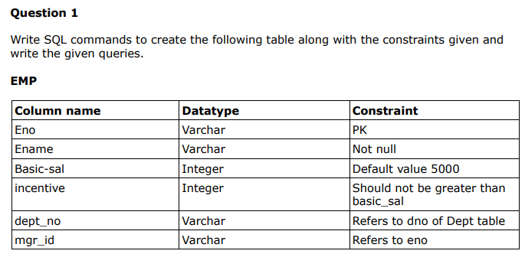

CREATE TABLE EMP(

eno VARCHAR PRIMARY KEY,

ename VARCHAR NOT NULL,

basic-sal INT DEFAULT '5000',

incentive INT CHECK(incentive <= basic_sal),

dept_no VARCHAR,

mgr_id VARCHAR,

FOREIGN KEY dept_no REFERENCES DEPT(dno),

FOREIGN KEY mgr_id REFERENCES EMP(eno) );

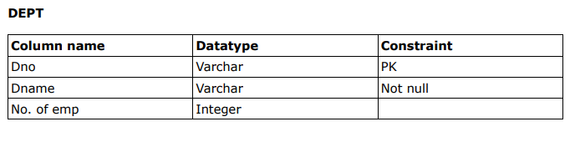

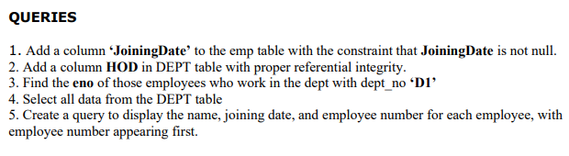

1. ALTER TABLE EMP ADD JoiningDate DATE NOT NULL;
2. ALTER TABLE DEPT ADD HOD VARCHAR, ADD FOREIGN KEY (HOD) REFERENCES EMP(eno);
3. SELECT eno FROM EMP WHERE dept_no = 'D1';
4. SELECT * FROM DEPT;
5. SELECT eno, ename, joiningdate FROM EMP

CREATE TABLE DEPT(

dno VARCHAR PRIMARY KEY,

dname VARCHAR NOT NULL,

no_of_employees INT );

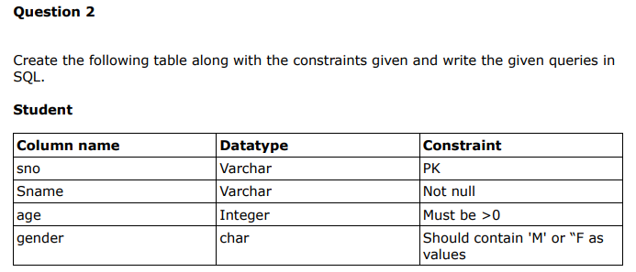

CREATE TABLE STUDENT(

sno VARCHAR PRIMARY KEY,

sname VARCHAR NOT NULL,

age INT CHECK(age > 0),

gender CHAR CHECK(gender IN ('M','F')) )

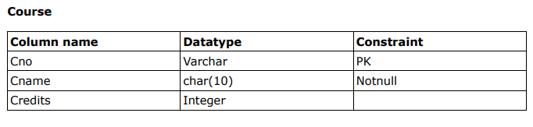

CREATE TABLE COURSE(

cno VARCHAR PRIMARY KEY,

canme CHAR(10) NOT NULL,

credits INT );

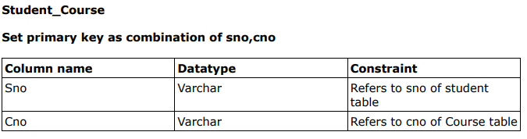

CREATE TABLE Student_Course (

sno VARCHAR,

cno VARCHAR,

PRIMARY KEY (sno, cno),

FOREIGN KEY (sno) REFERENCES STUDENT(sno),

FOREIGN KEY (cno) REFERENCES COURSE(cno) );

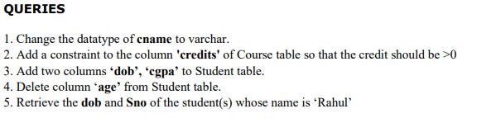

1. ALTER TABLE COURSE ALTER COLUMN cname TYPE VARCHAR;
2. ALTER TABLE COURSE ADD CONSTRAINT check_credits CHECK(credits > 0)
3. ALTER TABLE Student ADD COLUMN dob DATE, ADD COLUMN cgpa DECIMAL;
4. ALTER TABLE STUDENT DROP COLUMN age;
5. SELECT dob,sno FROM STUDENT WHERE sname = 'Rahul';

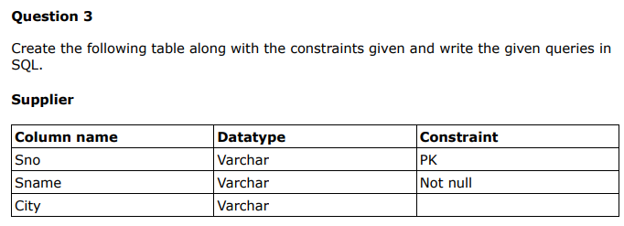

CREATE TABLE supplier(

sno VARCHAR PRIMARY KEY,

sname VARCHAR NOT NULL,

CITY VARCHAR );

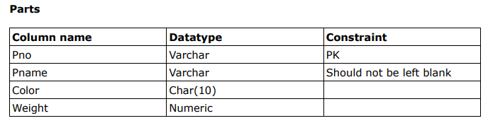

CREATE TABLE parts(

pno VARCHAR PRIMARY KEY,

pname VARCHAR NOT NULL,

color CHAR(10),

weight NUMERIC );

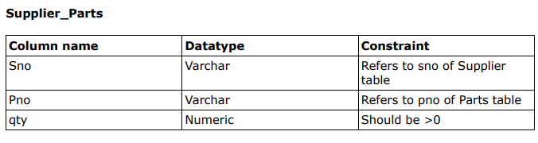

CREATE TABLE supplier_parts(

sno VARCHAR,

pno VARCHAR,

qty NUMERIC,

CHECK (qty > 0),

FOREIGN KEY (sno) REFERENCES supplier(sno),

FOREIGN KEY (pno) REFERENCES parts(pno) );

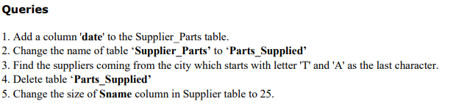

1. ALTER TABLE supplier_parts ADD COLUMN date DATE;
2. ALTER TABLE supplier_parts RENAME TO parts_supplied;
3. SELECT sname FROM supplier WHERE city LIKE 'T%A';
4. DROP TABLE parts_supplied;
5. ALTER TABLE supplier ALTER COLUMN sname TYPE VARCHAR(25);



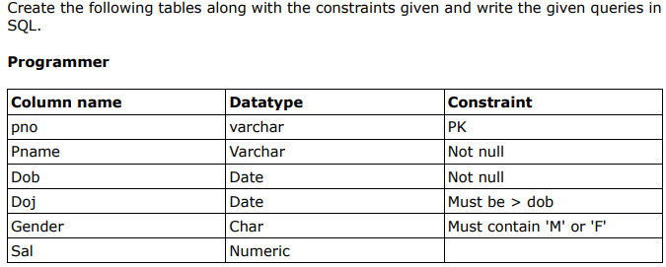

CREATE TABLE programmer(

pno VARCHAR PRIMARY KEY,

pname VARCHAR NOT NULL,

dob DATE NOT NULL,

doj DATE NOT NULL,

gender CHAR,

sal NUMERIC,

CONSTRAINT doj_check CHECK(doj > dob),

CONSTRAINT gender_check CHECK(gender IN('M','F')) );

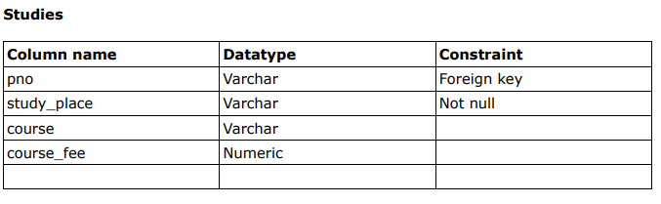

CREATE TABLE studies(

pno VARCHAR,

study_place VARCHAR,

course VARCHAR,

course_fee NUMERIC,

FOREIGN KEY(pno) REFERENCES programmer(pno) );

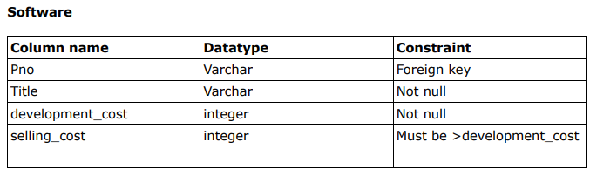

CREATE TABLE software(

pno VARCHAR,

title VARCHAR NOT NULL,

development_cost INT NOT NULL,

selling_cost INT,

FOREIGN KEY (pno) REFERENCES programmer(pno),

CONSTRAINT selling_check CHECK(selling_cost > development_cost) );

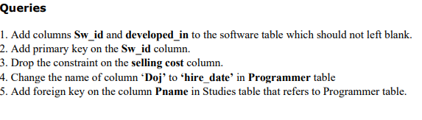

1. ALTER TABLE software ADD COLUMN sw_id VARCHAR NOT NULL, ADD COLUMN developed_in VARCHAR NOT NULL;
2. ALTER TABLE software ADD CONSTRAINT prime PRIMARY KEY(sw_id);
3. ALTER TABLE software DROP CONSTRAINT selling_check;
4. ALTER TABLE programmer RENAME COLUMN doj TO hire_date